**Personal Details**

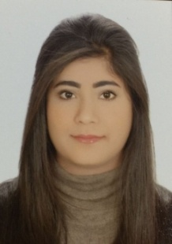**Name jameela nabeel ebrahim**

**Nationality Bahraini**

**Date of birth 14 April 1995**

**Address Hamad Town , BAHRAIN**

**Mobile 36922088**

**E-mail** [**jameelanabeel95@gmail.com**](mailto:jameelanabeel95@gmail.com)

**CRR NO 950403440**

**Objective**

* Seeking a job that suits my qualifications, my area of study and interests to strengthen, enhance and utilize the theoretical and practical knowledge in the rights of law.
* and I want to succeed and excel in the field of work and achieve my goals.
* **Self development and job advancement to maximum success.**

**Education and Qualifications**

* **2010-2013 Secondary certificate-the path of standardization of literary Hamad Town**

**Secondary Girls School.**

* **2013-2019 B.S College of law university of Bahrain .**

**Work experience**

* **2017-2018 Ahmad jassim law office and partners.**

**Activities**

* **Community service course in Hamad health center in 2013.**

**Hobbies**

* **Reading stories**
* **Swimming & Badminton**
* **Art design**

**References**

**Available upon request.**